Lab 4 Answers
Name: Ruturaj Sushil Ghodke
Student No: 3775789

Ping Pong Timing Table:

Message Size (bytes) | Iterations (K) | Avg RTT (s) | Est. One-way Latency (s)
1 | 10000 | 0.000000971 | 0.000000486
8 | 10000 | 0.000000686 | 0.000000343
64 | 10000 | 0.000000905 | 0.000000452
512 | 10000 | 0.000001753 | 0.000000877
4096 | 10000 | 0.000004209 | 0.000002104
65536 | 10000 | 0.000018923 | 0.000009461

Attaching screenshot of above run:
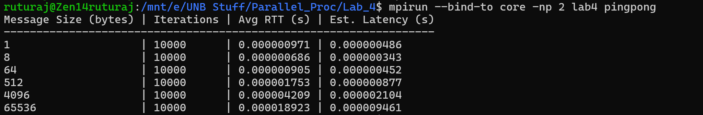

Short Answers:

Part A:

- How is message size controlled?
The message size is controlled through the dynamic allocation of a raw byte buffer using malloc(msg_size). This size is then explicitly passed as the count parameter in the MPI_Send and MPI_Recv functions, utilizing the MPI_BYTE datatype to ensure the exact number of bytes is transmitted.

- How is correctness verified?
System integrity is verified using MPI message tags rather than payload inspection. Tags are derived from the iteration number i. The receiving process validates the exchange by checking status.MPI_TAG against the expected iteration tag to ensure message synchronization.

Part B:

- Why is timing performed on Rank 0 only?
Timing is performed exclusively on Rank 0 to eliminate potential inaccuracies stemming from clock synchronization issues between different physical processors. This methodology ensures a consistent measurement of the total elapsed time for the full round-trip journey.

- Why is RTT/2 only an approximation of one-way latency?
The calculation of RTT/2 is considered an approximation because it assumes a perfectly symmetric network path. In practice, this does not account for independent variables such as asymmetric network congestion, routing differences, or varying OS overhead during the send and receive phases.

Ring Behavior Confirmation:
The ring behavior was tested with processes > 2, and each rank successfully received the rank of its left neighbor. Attaching a screenshot of a run with 8 processes.



